Admin Tools Workflow

|  |  |
| --- | --- |
| **I. Login**   1. After the user enters their User Name and Password the login button will log them in |  |
|  |  |

|  |  |
| --- | --- |
|  |  |
|  |  |

|  |  |
| --- | --- |
| **II. POI Manager**   1. The user can click on the POI Title name in order to modify that POI |  |
|  |  |

|  |  |  |
| --- | --- | --- |
| **III. Edit POI**   1. Once the user has selected a POI to edit users can make changes inside the POI Edit page. Here users can edit text and pictures of the selected POI. The Admin must click the save button to make any changes final to the database. | |  |
| **IV. Add New Place**   1. User selects the “New” button. 2. Allows the user to enter data for a new POI, after the user is finished they click “Add” to add the POI to the database |  | |
|  |  | |

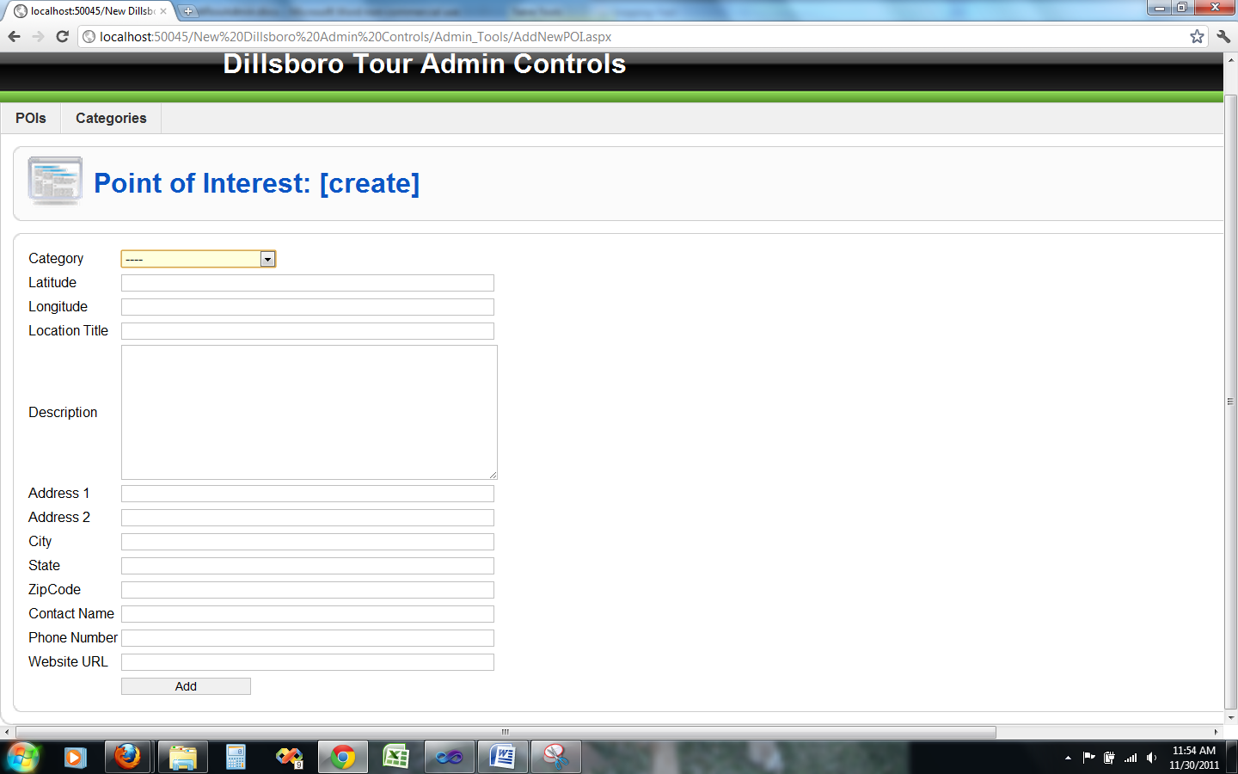

**V. Edit Categories**

* 1. User selects the Categories tab in the top left corner.
  2. Then the user can select which category they want to edit by clicking on the category.
  3. Users can also delete categories by selecting the “X” button beside each category.

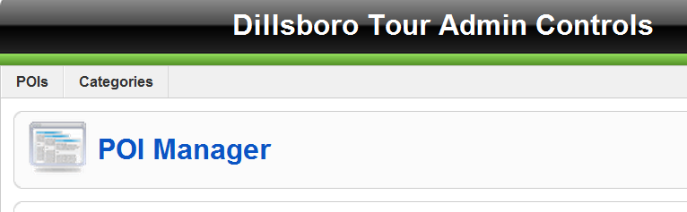

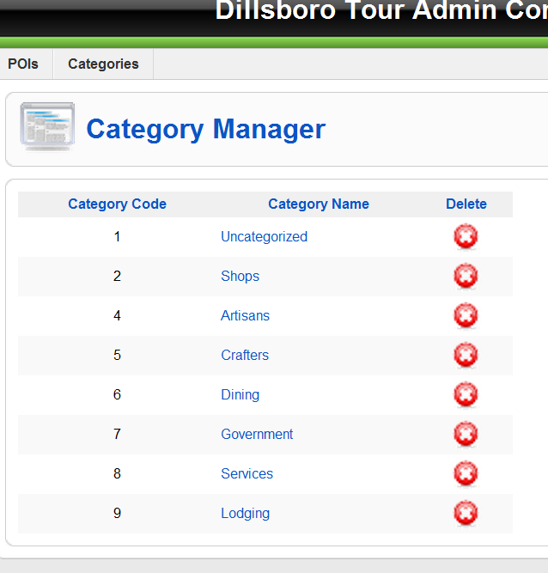

**VI. Add Categories**

* 1. User selects the Categories tab in the top left corner.
  2. Then the user selects the “New Category” button in the top corner.
  3. The user can then create a category by naming it and clicking the “create” button.

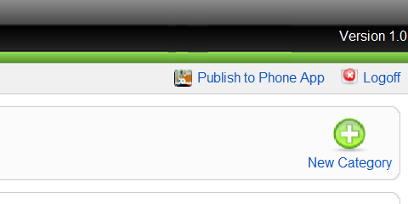

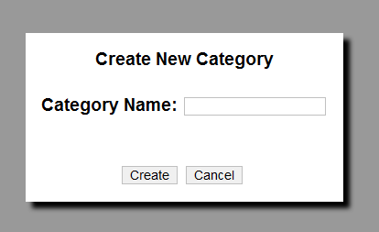

**VII. Save Changes**

* 1. User selects the “Publish to Phone App” button in the top right corner to save changes.

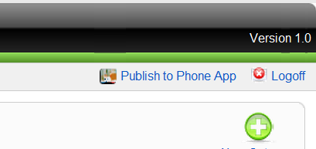

**VII. Log Off**

* 1. User selects the “Logoff” button in the top right corner. User is returned to log in screen.

